Svimjisamband Føroya is pleased to invite you to take part in

Nordic Junior Championships/Nordic Championships 2013
Date and place: December 6th to 8th 2013 in Tórshavn, Faroe Islands
Venue: Svimjihøllin í Gundadali, Tórshavn, Indoor pool 25 m, 6 lanes,
Omega electronic timing.

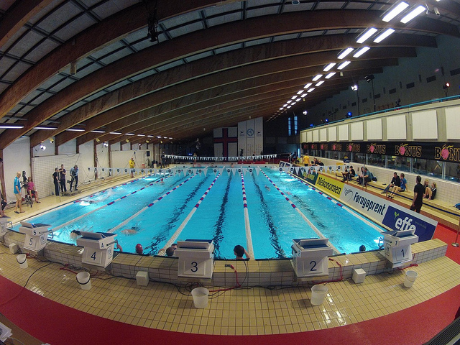

Age groups: Junior - Girls born 1998–1999, Boys born 1996–1997
Senior - Girls born 1995–1997, Boys born 1993–1995
Invited Nations: Denmark, Estonia, Faroe Islands, Finland, Iceland, Norway and
Sweden
The competition: See program on page below
Session 1: Friday 6/12. at 9:30
Session 2: Friday 6/12 time TBD
Session 3: Saturday 7/12 at 9:30
Session 4: Saturday 7/12 time TBD
Session 5: Sunday 8/12 at 9:30
Session 6: Sunday 8/12 time TBD
Each nation may enter 4 swimmers in each individual event in the prelims, 2 swimmers in each event in finals and one team in the relay events. 800/1500 meters events will be swum as timed finals.
The finals in 50 m are open for both age groups only one winner Nordic Champion.
Warm up 1,5 hours before the start of the session. Training will be possible in the competition pool on Thursday evening December 5th.
All the Finals session will be transmitted live on Faroese Television and on the net.
Technical Meeting: The technical meeting will take place on Thursday evening at 19:00. Changes can be made until 1,5 hour before each session.

Entries: Attached you will find Preliminary Entry Forms.
Please return your entries to Svimjisamband Føroya, PO Box 1329, FO-110 Tórshavn.
Fax.+298 317559 or e-mail: ssf@ssf.fo

Dates: Preliminary Entry/Booking: September 14th
Reservation payment 50%: September 19th
Final Entry/Booking: November 1st
Final payment: November 1st
Entry by Name: November 25th

Accommodation: Accommodation will be arranged at Hotel Føroyar (Address:
Oyggjarvegur 45, FO-100 Tórshavn) http://www.hotelforoyar.com
Full board will include breakfast at the hotel and lunch and dinner at other venue. The package includes accommodation from Thursday to Monday and dinner on Thursday and lunch and dinner from Friday to Sunday.
Package prices per person (€)
Single: 768,00 EUR
Twin: 596,00 EUR
Triple: 562,00 EUR
4-6 bed room: 499.00 EUR (Annex, 100 m from hotel, shared facilities)

The participating Federations will receive an invoice after the preliminary reservation. The invoice will include 50% of the total amount. After the Final entry booking the Federations will receive an invoice of the remaining amount.

Transportation: Travel Pack:
The Travel Pack, includes transportation from and to Copenhagen Airport, Kastrup and transportation to/from Vágar Airport.
Dec. 5th Dep. 12:30 Arr. 13:30 RC453, CPH-FAE
Dec. 9th Dep. 08:15 Arr. 11:15 RC450, FAE-CPH
For the Icelandic team, the Travel Pack will include travel for FAE-RKV on monday December 9th.

Travel Pack per person (€): 433,00 EUR
This offer is only for the countries that make their accommodation booking through the organizers. There will be shuttle service between the hotel and the pool, distance is 1500 m.

Information: Information about the Nordic Junior Championships, can be found here: http://www.njc2013.org

Information about Faroe Islands and the city of Tórshavn, can be found here: http://www.visittorshavn.fo/?l=en&

If you have any questions concerning the Nordic Junior Championships do not hesitate to contact us:

Svimjisamband Føroya
PO Box 1329
FO-110 Tórshavn

tel. +298 607559
fax +298 317559
e-mail ssf@ssf.fo

Competition Schedule

Friday 06/12 Heats at 9:30, Finals time tbd
1. Girls 200 m Freestyle
2. Boys 200 m Freestyle
3. Girls 100 m Breaststroke
4. Boys 100 m Breaststroke
5. Girls 100 m Backstroke
6. Boys 100 m Backstroke
7. Girls 50 m Butterfly Open NJM/NM
8. Boys 50 m Butterfly Open NJM/NM
9. Girls 200 m Indiv. medley
10. Boys 200 m Indiv. medley
11. Girls 800 m Freestyle
12. Boys 1500 m Freestyle
13. Girls 4x100 m Freestyle
14. Boys 4x100 m Freestyle
Saturday 07/12. Heats at 9:30, Finals time tbd
15. Girls 50 m Breaststroke Open NJM/NM
16. Boys 50 m Breaststroke Open NJM/NM
17. Girls 100 m Freestyle
18. Boys 100 m Freestyle
19. Girls 100 m Butterfly
20. Boys 100 m Butterfly
21. Girls 400 m Indiv. medley
22. Boys 400 m Indiv. medley
23. Girls 50 m Backstroke Open NJM/NM
24. Boys 50 m Backstroke Open NJM/NM
25. Girls 4x200 m Freestyle
26. Boys 4x200 m Freestyle
Sunday 08/12 Heats at 9:30, Finals time tbd
27. Girls 50 m Freestyle Open NJM/NM
28. Boys 50 m Freestyle Open NJM/NM
29. Girls 200 m Backstroke
30. Boys 200 m Backstroke
31. Girls 200 m Breaststroke
32. Boys 200 m Breaststroke
33. Girls 400 m Freestyle
34. Boys 400 m Freestyle
35. Girls 200 m Butterfly
36. Boys 200 m Butterfly
37. Girls 4x100 m Medley
38. Boys 4x100 m Medley
39. 8x50 Mixed freestyle (non scoring for team-trophy)
NORDIC JUNIOR CHAMPIONSHIPS/NORDIC CHAMPIONSHIPS 2013

PRELIMINARY ENTRY FORM
Please send Preliminary Entry Form to Svimjisamband Føroya by September 14th 2013 the latest. Email: ssf@ssf.fo or fax: +298 317559

Team info
Federation:
Address:
Contact person:
Telephone:
Email:

Size of team
Boys Junior:
Girls Junior:
Boys pre-senior:
Girls pre-senior:
Team staff:
Total:

Preliminary Hotel booking (Hotel Føroyar) – first come, first served basis
Single rooms: € 768,- per person
Double rooms: € 596,- per person
Triple rooms: € 562,- per person
4-6 persons/room annex by Hotel with shared facilities: € 499,- per person

Package prices include full board accommodation (3 meals per day) starting from Thursday with dinner to ending at Monday with breakfast.

Travel Package
Kastrup Airport – Hotel Føroyar – Kastrup Airport: € 433,- per person

Deadline September 14th 2013!

